| **Task: Project: Interpretation of Data Visualization** | | | |
| --- | --- | --- | --- |
| **Topic:** | Module 1: Thinking about Data, Working with Data | **Week No.** |  |
| **Course Code:** | ITEP 203 | **Term:** | 1st Semester |
| **Course Title:** | Quantitative Method including Modeling and Simulation | **Academic Year:** | 2020-2021 |
| **Student Name** |  | **Section** |  |
| **Due date** |  | **Points** | **50** |

This learning activity will help attain the intended learning outcomes of this module and will solidify the objectives of the module.

**Interpret a Data Visualization**

**Direction:** A large part of working with data is being able to interpret data visualizations and explain your insights to others. To give you some practice with this, we have selected a few Tableau dashboards for you to explore. The links are below, under "Choose from these Dashboards." Choose one of these dashboards, whichever one interests you the most, and find **three insights** in the visualizations. For each insight, **provide a static image** that shares what you found. Write a short report explaining each observation and how you found the information to reach your conclusion from the dashboard. Altogether (including images), your report should be 1-2 pages.

**Choose from these dashboards**

[Madrid in Detail](https://public.tableau.com/en-us/gallery/madrid-details?gallery=featured)

[Malaria in Africa](https://public.tableau.com/en-us/gallery/malaria-africa?gallery=featured)

[LinkedIn Top Skills](https://public.tableau.com/profile/matt.chambers#!/vizhome/LinkedInTopSkills2016-MakeoverMonday/LinkedInTopSkills2016-MakeoverMonday)

**RUBRIC SPECIFICATION**

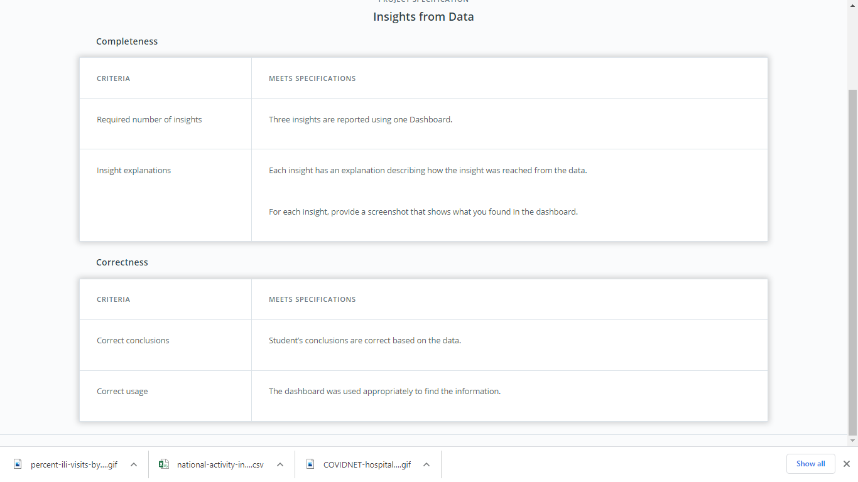

**Adapted from Udacity: https://review.udacity.com/#!/rubrics/1063/view**

**Reminders:**

1. AVOID PLAGIARISM, include the source/reference of the performance task output.
2. Save your quiz as **M1P1**-[Section]-[Surname] e.g. **M1P1-2F-BERNARDINO**